Table of Contents

1. Executive Summary
2. Introduction
   * Background on the e-commerce company and the festival sales event.
   * Purpose and scope of the analysis.
   * Methodology used for data collection and analysis.
3. Customer Demographics & Behavior Analysis
   * 3.1 Age Group Distribution
   * 3.2 Gender Distribution
   * 3.3 Marital Status and Purchasing Behavior
   * 3.4 Customer Occupations
   * 3.5 Average Orders and Spending
4. Product Performance Analysis
   * 4.1 Popular Product Categories
   * 4.2 Average Order Value by Product Category
   * 4.3 Statistical Measures for Sales Amount and Volume
5. Sales & Marketing Effectiveness Analysis
   * 5.1 Revenue by Zones/States
   * 5.2 Customer Age/Gender Influence on Spending
   * 5.3 Purchasing Behavior Across Occupations
6. Operational Efficiency Analysis
   * 6.1 Order Distribution Across Zones
   * 6.2 Geographic Areas with High/Low Order Volumes
7. Customer Segmentation Analysis
   * 8.1 Customer Segments Based on Demographics
   * 8.2 Purchasing Habits of Customer Segments
   * 8.3 Most Valuable Customer Segments
8. Strategic Recommendation

**1. Executive Summary**

This report provides a comprehensive analysis of the e-commerce festival sales event for [Your E-commerce Company Name], focusing on customer demographics and behavior, product performance, sales and marketing effectiveness, operational efficiency, and customer segmentation. The analysis aims to identify key trends, opportunities, and challenges to optimize future festival sales strategies and drive business growth.

**Key Findings:**

* **Customer Insights:** The dominant customer segments are females aged 26-35, primarily unmarried and employed in the IT sector. These customers exhibit high engagement and spending, making them a key target for marketing efforts.
* **Product Performance:** "Clothing & Apparel," "Food," and "Electronics & Gadgets" are the most popular product categories. However, there is a long tail of niche categories with lower demand, requiring targeted marketing and product assortment strategies.
* **Sales & Marketing Effectiveness:** Revenue is concentrated in the Metro and Northern regions, with Uttar Pradesh, Maharashtra, and Karnataka leading in sales. Targeted marketing campaigns and regional strategies are crucial to maximize revenue generation.
* **Operational Efficiency:** The Central zone demonstrates the highest order volume, while the Eastern zone lags, indicating potential operational challenges. Optimizing logistics and resource allocation across zones is essential to improve efficiency.
* **Customer Segmentation:** Metro and Northern customers are the most valuable segments, demonstrating high order frequency and spending. Tailored marketing and customer experience strategies are crucial to retain and grow these segments.

**Strategic Recommendations:**

* **Focus on High-Value Customers:** Develop targeted marketing campaigns and loyalty programs for Metro and Northern customers, as well as females aged 26-35.
* **Optimize Product Strategy:** Ensure adequate inventory for popular categories, while implementing targeted marketing for niche categories.
* **Enhance Regional Strategies:** Develop regional marketing campaigns and optimize resource allocation based on zone-specific demand and operational efficiency.
* **Improve Operational Efficiency:** Address operational bottlenecks in the Eastern zone and optimize logistics and distribution across all zones.
* **Personalize Customer Experience:** Tailor the customer experience to different segments based on their purchasing habits and preferences.

By implementing these recommendations, [Your E-commerce Company Name] can leverage the insights from this analysis to optimize future festival sales strategies, enhance customer satisfaction, and drive sustainable business growth.

**2. Introduction**

his report provides a comprehensive analysis of the e-commerce festival sales performance of Aditya Store. The data used for this analysis was extracted from an Excel file containing detailed transactional records for the festival period. To facilitate analysis, this data was then imported into a SQL database, where various queries were designed and executed to aggregate, transform, and analyze the data to extract meaningful insights.

The primary objective of this analysis is to gain a deep understanding of various aspects of Aditya Store's performance during the festival sales event. This includes:

* **Customer Demographics:** We delve into the characteristics of Aditya Store's customer base, including age, gender, marital status, and occupation. This detailed understanding of customer demographics will enable the development of targeted marketing campaigns and personalized customer experiences, leading to increased customer engagement and satisfaction.
* **Product Trends:** We identify the most popular product categories and analyze customer preferences to understand which products resonate most with the customer base. This information will be used to optimize product assortment, inventory management, and marketing strategies to ensure that Aditya Store is offering the right products at the right time.
* **Sales and Marketing Effectiveness:** We evaluate the effectiveness of sales and marketing efforts during the festival period by analyzing revenue generated across different zones and states. We also investigate the influence of customer demographics on spending patterns to identify high-value customer segments and tailor marketing messages accordingly.
* **Operational Efficiency:** We assess the efficiency of order fulfillment and delivery processes by analyzing order distribution across different zones. This analysis will help identify potential bottlenecks and areas for improvement in logistics and supply chain management to ensure timely delivery and a seamless customer experience.

The insights derived from this comprehensive analysis will serve as the foundation for developing data-driven strategies to enhance future festival sales performance and drive overall business growth for Aditya Store. The report will provide specific, actionable recommendations for optimizing marketing campaigns, product offerings, customer engagement strategies, and operational efficiency to maximize revenue generation and customer satisfaction..

* 1. **Customer Demographics & Behavior Analysis**
  + **3.1 Age Group Distribution**
  + **3.2 Gender Distribution**
  + **3.3 Marital Status and Purchasing Behavior**
  + **3.4 Customer Occupations**
  + **3.5 Average Orders and Spending**

**3.1 Age Group Distribution**

**Key Insights:**

* Dominant Age Group: The 26-35 age group is the largest customer segment (4,543 customers), indicating a strong preference for Aditya Store's offerings among this demographic.
* Significant Younger Segment: The 18-25 age group is also a significant segment (1,879 customers), representing a valuable customer base with potential for long-term loyalty.
* Decline in Older Segments: Customer numbers decline noticeably after the 36-45 age group, suggesting a need for strategies to retain older customers and cater to their specific needs.
* Potential in Younger Segment: The 0-17 age group, while smaller (296 customers), still presents an opportunity, particularly for family-oriented products and targeted marketing efforts.
* Substantial Mid-Age Segment: The 36-45 age group is also substantial (2,286 customers), indicating a need to cater to their specific needs and preferences.

**Business Actions:**

* Targeted Marketing: Develop targeted marketing campaigns for the 26-35 and 18-25 age groups, focusing on their specific interests and preferences.
* Product Development: Create or promote products that appeal to the dominant age groups, ensuring alignment with their lifestyle and purchasing habits.
* Retention Strategies: Implement personalized strategies to retain older customers (46+), such as loyalty programs, exclusive offers, and tailored communication.
* Engagement of Younger Segment: Explore opportunities to engage the 0-17 age group through family-oriented products, kid-friendly promotions, and relevant marketing channels.
* Data-Driven Decisions: Continuously analyze age group data to identify trends, refine strategies, and make informed business decisions.

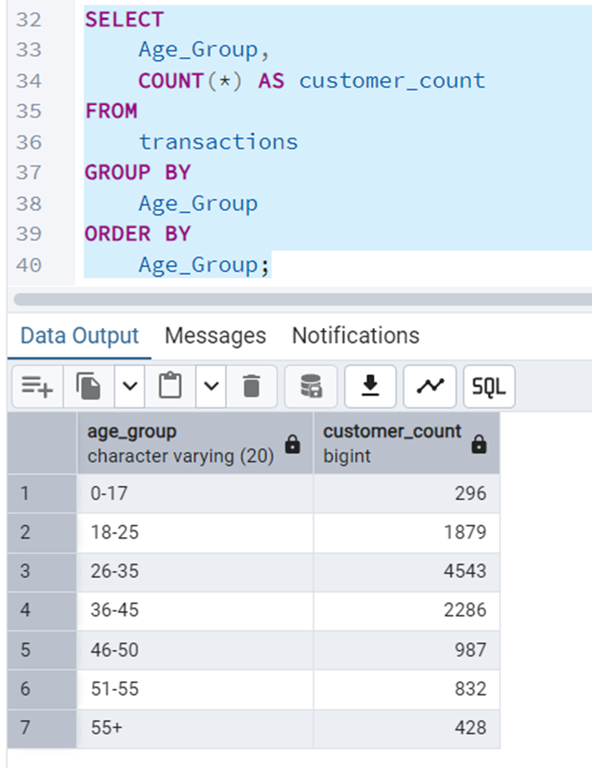

**3.2 Gender Distribution**

**Key Insights:**

* Female Dominance: There are significantly more female customers (7,842) than male customers (3,409).
* Females as Majority: Females represent over twice the customer base of males, indicating a strong preference for Aditya Store's offerings among female shoppers.

**Business Actions:**

* Prioritize Female Focus: Prioritize female-focused marketing and product development to cater to the largest customer segment.
* Improve Male Engagement: Analyze the reasons for lower male customer engagement and develop targeted strategies to attract and retain male customers.
* Tailored Communication: Tailor communication and messaging to resonate with the female audience, using appropriate language, imagery, and channels.
* Female-Centric Experience: Design a female-centric customer experience, considering their preferences and needs in product offerings, website design, and customer service.
* Monitor Trends: Use data to monitor trends in gender distribution and segment analysis to adapt strategies and optimize marketing efforts.

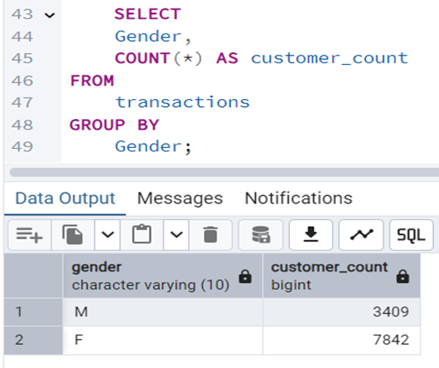

**3.3 Marital Status and Purchasing Behavior**

* **Marital Status 0 (Unmarried):** 
  + Customer Count: 6,522
  + Average Spending: 9,531.36
  + Total Spending: 62,125,386.44
* **Marital Status 1 (Married):** 
  + Customer Count: 4,729
  + Average Spending: 9,346.27
  + Total Spending: 44,123,745.99

**Calculations and Ratios:**

* Difference in Customer Count: 6,522 (Unmarried) - 4,729 (Married) = 1,793 more unmarried customers.
* Ratio of Unmarried to Married Customers: 6,522 / 4,729 ≈ 1.38 (Approximately 1.38 unmarried customers for every married customer).
* Difference in Average Spending: 9,531.36 (Unmarried) - 9,346.27 (Married) = 185.09 higher average spending by unmarried customers.
* Percentage Difference in Average Spending: (185.09 / 9,346.27) * 100% ≈ 1.98% higher average spending by unmarried customers.
* Difference in Total Spending: 62,125,386.44 (Unmarried) - 44,123,745.99 (Married) = 18,001,640.45 higher total spending by unmarried customers.
* Percentage Difference in Total Spending: (18,001,640.45 / 44,123,745.99) * 100% ≈ 40.80% higher total spending by unmarried customers.

**Detailed Key Insights:**

1. **Customer Count Disparity:** 
   * There is a significant difference in customer count, with unmarried customers outnumbering married customers by approximately 1,793.
   * The ratio of unmarried to married customers is approximately 1.38, indicating a larger unmarried customer base.
2. **Average Spending Variation:** 
   * Unmarried customers have a slightly higher average spending than married customers (approximately 1.98% higher).
   * This suggests that unmarried customers may have different purchasing priorities or spending habits.
3. **Total Spending Dominance:** 
   * Unmarried customers contribute significantly more to the total spending (approximately 40.80% higher).
   * This is due to both the higher customer count and slightly higher average spending**.**

**Actionable Strategies:**

**For Unmarried Customers:**

* **Targeted Marketing:** 
  + Develop marketing campaigns that resonate with the lifestyles and preferences of unmarried individuals.
  + Focus on promoting products and services that cater totheir specific needs, such as travel, entertainment, and personal care.
* **Product Recommendations:** 
  + Personalize product recommendations based on their browsing and purchasing history.
  + Highlight products that are popular among unmarried customers or align with their interests.
* **Promotional Offers:** 
  + Offer exclusive discounts and promotions for unmarried customers.
  + Consider creating bundles or packages that cater to their specific needs.

**For Married Customers:**

* **Family-Oriented Marketing:** 
  + Develop marketing campaigns that focus on family-oriented products and services.
  + Highlight products that are suitable for couples and families, such as home goods, appliances, and children's products**.**
* **Bundle Offers:** 
  + Create bundle offers that are targeted towards married couples and families.

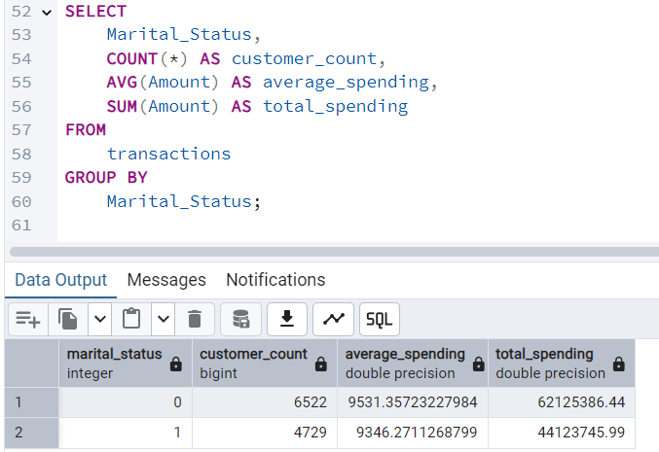

**3.4 Customer Occupations**

**Calculations and Ratios:**

1. **Total Customer Count:**
   * Sum of all customer counts: 1588 + 1408 + 1310 + 1139 + 854 + 705 + 637 + 566 + 542 + 531 + 501 + 423 + 414 + 350 + 283 = 10,251
2. **Percentage Distribution:**
   * Calculate the percentage of customers in each occupation relative to the total customer count.
   * Example: IT Sector: (1588 / 10251) * 100% ≈ 15.5%
3. **Top 4 Sectors Ratio:**
   * Sum of the top 4 sectors (IT, Healthcare, Aviation, Banking): 1588 + 1408 + 1310 + 1139 = 5445
   * Percentage of top 4 sectors: (5445 / 10251) * 100% ≈ 53.1%
4. **Bottom 5 Sectors Ratio:**
   * Sum of the bottom 5 sectors (Retail, Food Processing, Construction, Textile, Agriculture): 501 + 423 + 414 + 350 + 283 = 1971
   * Percentage of bottom 5 sectors: (1971 / 10251) * 100% ≈ 19.2%

**Key Business Insights:**

1. **Dominance of Top Sectors:** 
   * The top 4 sectors (IT, Healthcare, Aviation, Banking) constitute over 53% of the customer base, highlighting their significant contribution to Aditya Store's business.
   * This indicates a strong alignment between Aditya Store's offerings and the preferences of professionals in these sectors**.**
2. **Concentration of Customer Base:** 
   * The customer base is heavily concentrated in a few key sectors, suggesting a potential reliance on these sectors for revenue generation.
3. **Underrepresentation of Traditional Sectors:** 
   * The bottom 5 sectors (Retail, Food Processing, Construction, Textile, Agriculture) collectively represent less than 20% of the customer base, indicating a need for targeted strategies to expand market reach in these sectors.
4. **Potential for Diversification:** 
   * The diverse range of occupations represented in the customer base suggests potential for diversification and expansion into new markets**.**
5. **Hierarchy and Segmentation:** 
   * The clear hierarchy in customer count across different occupations highlights the importance of customer segmentation and tailored marketing strategies**.**

**Recommendations:**

1. **Prioritize Top Sectors:** 
   * Develop specialized marketing campaigns, loyalty programs, and product offerings for the top 4 sectors (IT, Healthcare, Aviation, Banking).
   * Focus on building strong relationships with professionals in these sectors to enhance customer loyalty and retention.
2. **Diversify Market Reach:** 
   * Conduct market research to understand the specific needs and preferences of customers in the bottom 5 sectors (Retail, Food Processing, Construction, Textile, Agriculture).
   * Develop targeted marketing campaigns and product offerings to attract customers from these sectors.

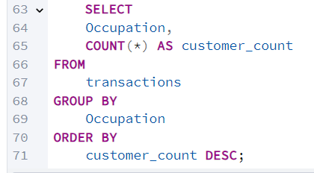

**3.5 Average Orders and spending**

**Calculations and Ratios:**

1. **Total Orders:**
   * Average Orders per Customer * Total Customer Count = 2.49 * 10,251 ≈ 25,525 orders
2. **Total Revenue:**
   * Average Amount Spent per Customer * Total Customer Count = 9453.61 * 10,251 ≈ 96,903,329.11
3. **Average Revenue per Order:**
   * Total Revenue / Total Orders = 96,903,329.11 / 25,525 ≈ 3,796.41
4. **Customer Engagement Index (Orders):**
   * This is already provided as 2.49 orders, indicating moderate engagement.

**Key Insights:**

1. **Moderate Customer Engagement:**
   * An average of 2.49 orders per customer suggests moderate engagement. While customers are making repeat purchases, there is significant room to increase interaction and loyalty.
2. **Substantial Average Spending:**
   * The average amount spent per customer (9453.61) indicates a relatively high value per customer, suggesting that customers are willing to invest in Aditya Store's products or services.
3. **Significant Total Revenue:**
   * The estimated total revenue of approximately 96.9 million highlights the substantial financial impact of Aditya Store's customer base.
4. **Average Order Value:**
   * The average revenue per order (3,796.41) provides a benchmark for evaluating the effectiveness of marketing campaigns and product promotions in driving higher order values.

**Recommendations:**

1. **Enhance Customer Engagement:**
   * Implement loyalty programs to incentivize repeat purchases and reward customer loyalty.
   * Personalize email marketing and product recommendations to increase customer interaction.
   * Offer exclusive promotions and discounts to encourage repeat purchases.
   * Create a customer feedback system to understand customer needs and improve engagement.
2. **Increase Average Order Value:**
   * Implement upselling and cross-selling strategies to encourage customers to purchase higher-value items or complementary products.
   * Offer bundled products or package deals to increase the average order value.
   * Highlight premium products or services to attract customers willing to spend more.

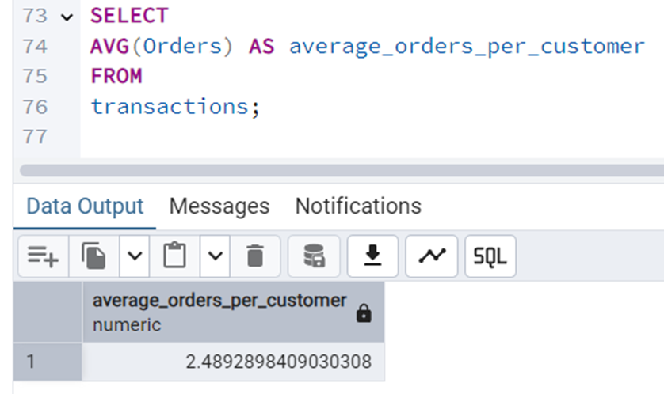

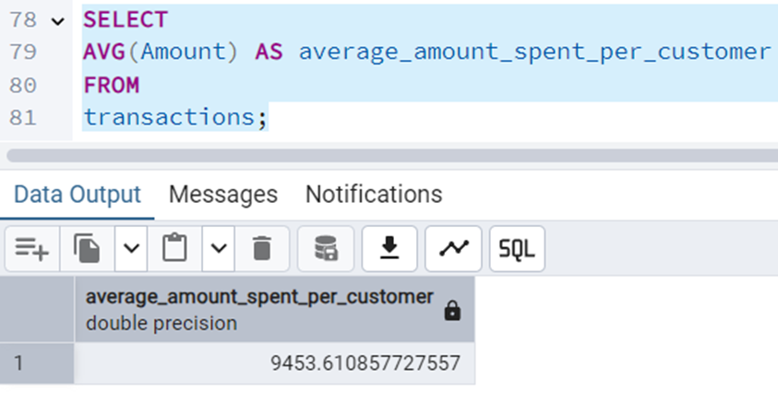

**4. Product Performance Analysis**

* + **4.1 Popular Product Categories**
  + **4.2 Average Order Value by Product Category**
  + **4.3 Statistical Measures for Sales Amount and Volume**

**1. Calculate Total Orders:**

* Sum of all order counts: 2655 + 2493 + 2087 + 1064 + 520 + 422 + 386 + 356 + 353 + 212 + 113 + 112 + 103 + 100 + 96 + 81 + 72 + 26 = 11,163

**2. Calculate Percentage Distribution:**

* Divide each category's order count by the total orders and multiply by 100.

Example: Clothing & Apparel (2655/11163) * 100 = 23.79%

**3. Calculate Top 3 Categories Ratio:**

* Sum of the top 3 (Clothing, Food, Electronics): 2655 + 2493 + 2087 = 7235
* Percentage of top 3: (7235 / 11163) * 100 = 64.81%

**4. Calculate Bottom 5 Categories Ratio:**

* Sum of the bottom 5 (Auto, Decor, Veterinary, Tupperware, Tools): 100 + 96 + 81 + 72 + 26 = 375
* Percentage of bottom 5: (375 / 11163) * 100 = 3.36%

**Key Business Insights:**

1. **Concentrated Demand:** 
   * The top 3 categories (Clothing, Food, Electronics) make up nearly 65% of all orders, demonstrating a strong concentration of customer demand**.**
2. **Essential and Popular Items:** 
   * Apparel and Food are essential categories, while Electronics are highly popular, driving a large portion of sales**.**
3. **Long Tail Effect:** 
   * The bottom 5 categories represent only 3.36% of total orders, highlighting a significant long-tail effect.
4. **Niche Categories:** 
   * Categories like Veterinary, Tupperware, and Hand & Power Tools have very low order volumes, indicating niche markets or potentially low demand.
5. **Varied Category Performance:** 
   * There is a significant variation in order volume across categories, indicating varied customer interest.

**Recommendations:**

1. **Optimize Top Categories:** 
   * Focus on inventory management and marketing for the top 3 categories to maximize sales.
   * Analyze customer preferences within these categories to tailor offerings.
2. **Evaluate Niche Categories:** 
   * Assess the profitability and viability of the bottom 5 categories.
   * Consider discontinuing or restructuring categories with consistently low performance.
3. **Targeted Marketing:** 
   * Develop targeted marketing campaigns for mid-range categories (Footwear, Household, Beauty) to increase their order volume**.**
4. **Product Bundling:** 
   * Explore product bundling strategies that combine popular categories with niche categories.
   * Example: Bundle "Electronics & Gadgets" with "Office" supplies.

**4.2 Average Order Value by Product Category**

* **Null Values:** 
  + Several categories (Auto, Food, Footwear & Shoes, Furniture) have null values for both product_sales and sales_share_percentage, indicating missing data**.**
* **High Performers:** 
  + "Clothing & Apparel" (P00265242) has sales of 87,910 and a 0.53% sales share.
  + "Electronics & Gadgets" (P00057642) has sales of 82,015 and a 0.52% sales share.
  + "Games & Toys" (P00059442) has sales of 51,860 and a 1.20% sales share.
  + "Sports Products" (P00110942) has sales of 43,393 and a 1.19% sales share.
  + "Hand & Power Tools" (P00144242) has sales of 30,856 and a 7.61% sales share.
  + "Stationery" (P00103042) has sales of 30,176 and a 1.80% sales share.
  + "Books" (P00249542) has sales of 30,765 and a 2.90% sales share.
  + "Tupperware" (P00182542) has sales of 21,079 and a 1.82% sales share.
  + "Decor" (P00026042) has sales of 19,670 and a 2.69% sales share.
  + "Beauty" (P00113142) has sales of 16,633 and a 0.85% sales share.
  + "Household items" (P0099042) has sales of 14,581 and a 0.93% sales share.
  + "Pet Care" (P00337542) has sales of 7,760 and a 1.69% sales share.
  + "Veterinary" (P00003942) has sales of 2,809 and a 2.49% sales share.
  + "Office" (P00195442) has sales of 1,910 and a 2.33% sales share.
* **Highest Sales Share:** 
  + **"**Hand & Power Tools" (P00144242) has the highest sales_share_percentage at 7.61%.

**Key Insights:**

1. Missing Data:
   * The presence of null values for several categories indicates data gaps that need to be addressed for accurate analysis.
2. Sales Concentration:
   * A few categories ("Clothing & Apparel," "Electronics & Gadgets," "Games & Toys," "Sports Products") drive a significant portion of sales.
3. High Sales Share in Niche Category:
   * "Hand & Power Tools" has the highest sales share, despite not having the highest sales volume, suggesting a potentially high-profit margin or strong customer loyalty in this niche.
4. Varied Sales Performance:
   * There is a wide range of sales performance across different product categories, indicating varied customer interest and demand.
5. Sales Share vs. Sales Volume:
   * Categories with high sales volume do not necessarily have the highest sales share, highlighting the importance of considering both metrics.

**Recommendations:**

1. Address Missing Data:
   * Investigate the reasons for missing data and implement data collection and validation procedures to ensure data completeness.
2. Focus on High-Performing Categories:
   * Prioritize marketing and inventory management for categories with high sales volume ("Clothing & Apparel," "Electronics & Gadgets").
3. Analyze Niche Category Success:
   * Investigate the factors contributing to the high sales share of "Hand & Power Tools."
   * Consider expanding product offerings or marketing efforts in this category.

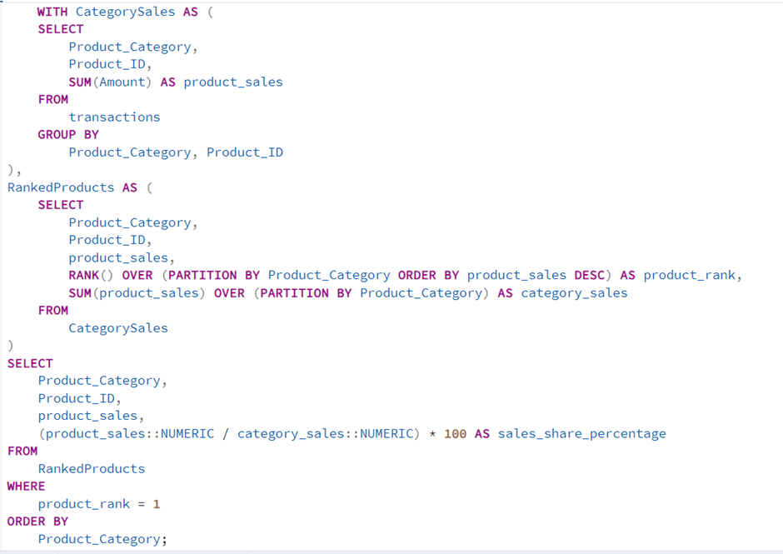

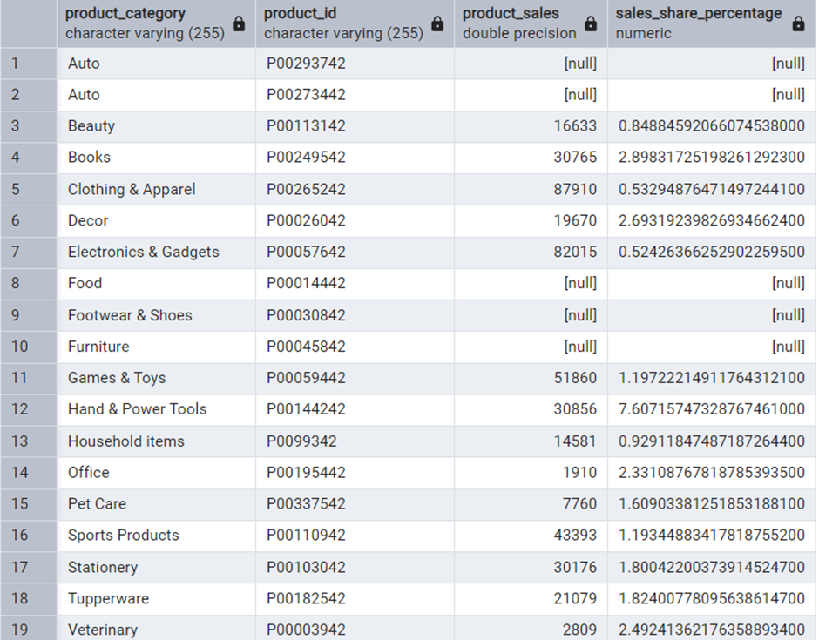

**4.3 Statistical Measures for Sales Amount and Volume**

**Key Insights with Numbers:**

1. **High Variability in Sales:**
   * The standard deviation of sales is 8,949,823.92, indicating a wide spread of sales figures. This means some products or categories have significantly higher sales than others.
   * The mean sales (5,902,729.58) is much higher than the median sales (1,817,330.75), suggesting a right-skewed distribution with a few very high sales values pulling the average up.
2. **Wide Range of Sales Performance:**
   * Sales figures range from a minimum of 81,936 to a maximum of 33,933,883.50, highlighting the disparity in sales performance across products or categories.
3. **Variability in Order Counts:**
   * The standard deviation of orders is 863.66, indicating a significant variation in order counts.
   * Similar to sales, the mean orders (625.06) is higher than the median orders (282.5), suggesting a right-skewed distribution with a few products or categories having a very high number of orders.
4. **Wide Range of Order Counts:**
   * Order counts range from a minimum of 26 to a maximum of 2,655, demonstrating the variability in order volume.
5. **Percentiles Highlight Distribution:**
   * 25% of sales values are below 813,139.50, and 75% are below 5,162,962.49, providing insights into the distribution of sales data.
   * Similarly, 25% of order values are below 100.75, and 75% are below 495.5, giving a sense of the typical order volume.

**Overall, these insights suggest that:**

* There are a few high-performing products or categories driving a significant portion of the sales and order volume.
* Many products or categories have relatively low sales and order counts.
* Businesses should focus on understanding the factors driving the success of high performers and develop strategies to improve the performance of low performers.
* Analyzing the data further by product category or other relevant attributes can provide more specific insights and actionable strategies.

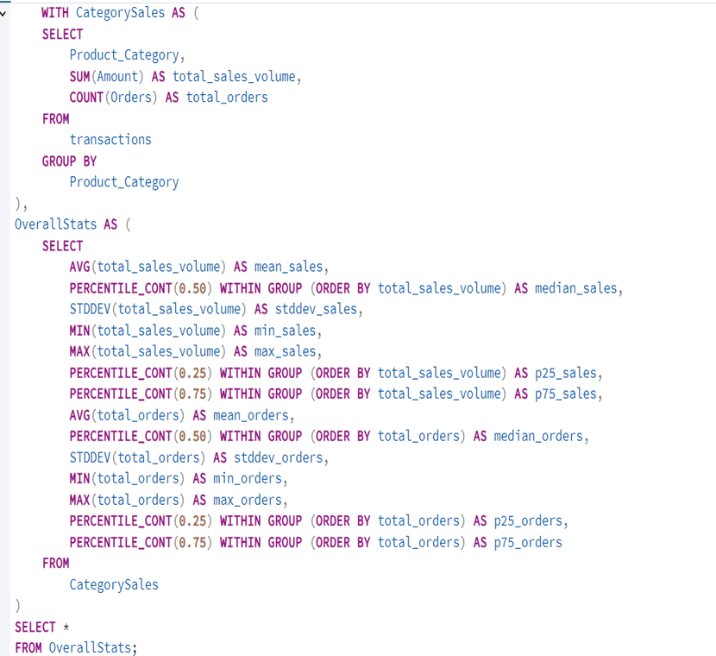

**5.Sales & Marketing Effectiveness Analysis**

* + **5.1 Revenue by Zones/States**
  + **5.2 Customer Age/Gender Influence on Spending**
  + **5.3 Purchasing Behavior Across Occupations**

**5.1 Revenue by Zones/States**

**Summary of State-wise Total Revenue:**

* Uttar Pradesh leads with the highest total revenue (19,374,968).
* Maharashtra and Karnataka follow as second and third highest (14,427,543 and 13,523,540 respectively).
* Delhi is the fourth highest, with 11,603,819.45 in revenue.
* There's a significant drop in revenue after the top four states.
* Madhya Pradesh and Andhra Pradesh have similar revenue figures (around 8 million).
* Himachal Pradesh, Haryana, Bihar, Gujarat, and Kerala have revenues between 3 and 5 million.
* Jharkhand and Uttarakhand have revenues between 2 and 3 million.
* Rajasthan and Punjab have revenues between 1 and 2 million.
* Telangana has the lowest revenue (1,151,490).
* There's a wide disparity in revenue across different states**.**

**Insights:**

* **Uneven Performance:** Revenue is not evenly distributed across states, with some significantly outperforming others.
* **Top Performers:** Uttar Pradesh, Maharashtra, and Karnataka are the top revenue generators.

**Low Performers:** Telangana, Punjab, and Rajasthan have the lowest revenue

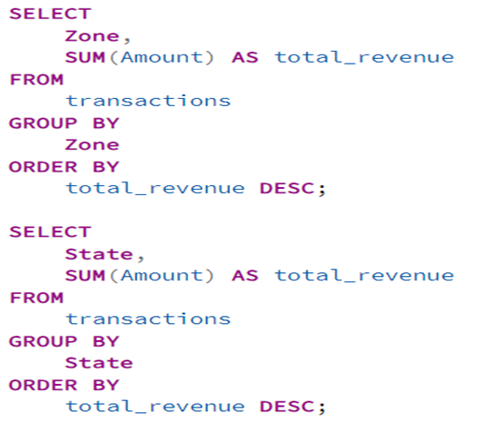

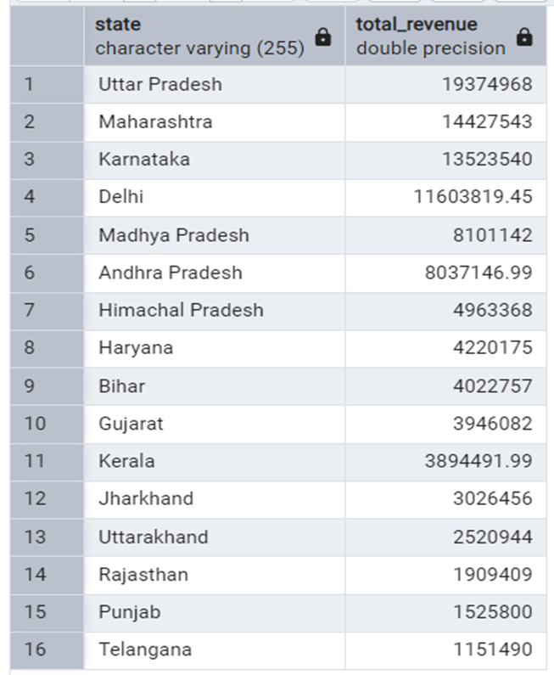

**5.2 Customer Age/Gender Influence on Spending**

**Key Insights:**

* **Age and Spending:**
  + Generally, average spending is quite high across all age groups and genders.
  + The 26-35 age group, both male and female, shows significant total spending, indicating a key demographic.
  + The 55+ male group has the highest average spending, suggesting a potentially affluent segment.
* **Gender Differences:**
  + In most age groups, males tend to have a higher average spending than females.
  + However, female customer counts are often higher, indicating a larger customer base.
* **Customer Count:**
  + The 26-35 age group, especially females, has the highest customer count, confirming its importance.
  + The 0-17 age group has the lowest customer count, particularly males.
* **Total Spending:**
  + The 26-35 female group has the highest total spending, reflecting both high customer count and average spending.
  + The 36-45 female group has the second highest total spending.

**Actionable Strategies:**

1. **Target the 26-35 Age Group:**
   * Develop marketing campaigns tailored to this demographic, focusing on both males and females.
   * Offer products and services that align with their lifestyle and spending habits.
2. **Capitalize on the 55+ Male Segment:**
   * Create premium offerings or personalized services for this affluent group.
   * Explore opportunities to build loyalty and long-term relationships.
3. **Address Gender Disparities:**
   * Investigate why males tend to spend more on average.
   * Consider targeted promotions or product recommendations to encourage female spending.
4. **Increase Customer Count in the 0-17 Age Group:**
   * If this segment is relevant to your business, explore family-oriented products or marketing strategies.
   * Look into what is causing the low male count.

.

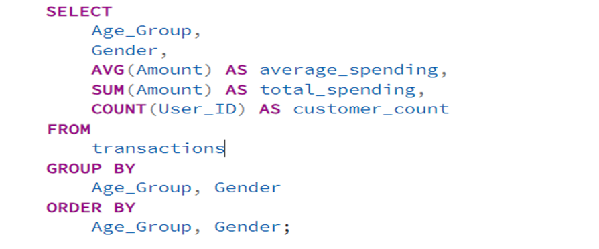

**5.3 Purchasing Behavior Across Occupations**

**Insights:**

1. **High-Value Sectors:**
   * "Banking" and "IT Sector" stand out with high total spending and customer counts, respectively. This suggests these sectors represent high-value customer segments.
   * "Govt" sector has the highest average spending, so though the customer count is not the highest, the customers that are from the Govt sector, spend the most on average.
2. **Spending Patterns:**
   * While average spending varies, the differences are not drastic. This could indicate that customers across different occupations have similar spending capacities or needs.
   * The total spending varies greatly because of the variation in the customer counts.
3. **Order Frequency Consistency:**
   * The average number of orders per customer is relatively consistent across occupations, hovering around 2.4 to 2.5 orders. This suggests a general trend in order frequency, regardless of occupation.
4. **Niche vs. Mass Markets:**
   * Occupations like "Textile" and "Agriculture" have lower customer counts, indicating niche markets, while "IT Sector" and "Banking" represent mass markets.

**Actionable Strategies:**

* **Target High-Value Sectors:**
  + Develop targeted marketing campaigns and loyalty programs for customers in the "Banking" and "IT Sector" to maximize their value.
  + Create special offerings for the "Govt" sector.
* **Analyze Low-Performing Sectors:**
  + Investigate why sectors like "Retail" and "Textile" have lower spending and customer counts.

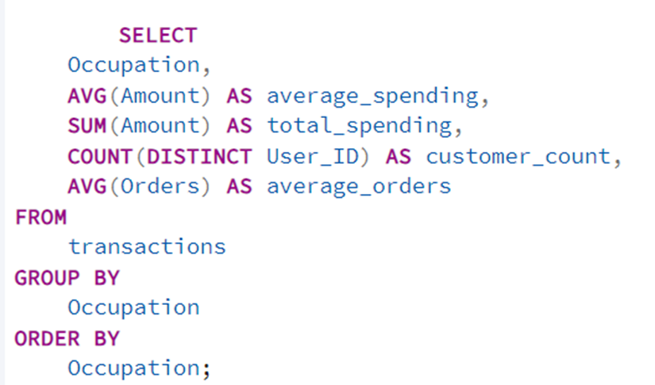

**6. Operational Efficiency Analysis**

* + **6.1 Order Distribution Across Zones**
  + **6.2 Geographic Areas with High/Low Order Volumes**

**6.1 Order Distribution Across Zones**

**Key Insights:**

1. **Central Zone Dominance:** The Central zone has the highest order count (4296), significantly more than any other zone. This suggests a strong market presence or operational efficiency in this area.
2. **Order Volume Hierarchy:** There's a clear hierarchy in order volume across zones: Central > Southern > Western > Northern > Eastern. This indicates varying levels of demand or operational effectiveness in each region.
3. **Significant Drop in Eastern Zone:** The Eastern zone has the lowest order count (814), significantly lower than the Northern zone (1491). This suggests potential operational challenges or market limitations in the Eastern region.
4. **Potential for Resource Allocation:** The varying order volumes suggest a need for strategic resource allocation across zones. The Central zone might require more resources to handle the higher volume, while the Eastern zone might need additional support to improve performance.

**6.2 Geographic Areas with High/Low Order Volumes**

**Combined Insights:**

1. **Central Zone Dominance & Uttar Pradesh:**
   * The Central zone has the highest order volume, and Uttar Pradesh (the top state) is likely a significant contributor to this. This suggests operational efficiency within the Central zone is crucial, and Uttar Pradesh's success needs to be understood.
   * **Action:** Analyze the logistics, marketing, and sales strategies used in Uttar Pradesh and the Central zone to identify best practices.
2. **Southern Zone & Karnataka/Maharashtra:**
   * The Southern zone is the second highest, and Karnataka and Maharashtra are the second and third highest states, respectively. This reinforces the strength of the Southern region.
   * **Action:** Ensure that operational capacity within the southern zone is able to keep up with the demand.
3. **Eastern Zone & Low State Volumes:**
   * The Eastern zone has the lowest order volume, and states like Jharkhand and Bihar in that general area reflect relatively low order volumes. This points to potential operational or market challenges in the Eastern region.
   * **Action:** Conduct a thorough investigation of the Eastern zone's operational infrastructure. Look into the market conditions in Jharkhand and Bihar to understand the low demand.
4. **Telangana & Low Volumes:**
   * Telangana has the lowest order volume across all states, and this aligns with potentially lower activity in the Southern zone compared to the Central.
   * **Action:** Conduct specific market research in Telangana to understand the reasons for the low order volume. Develop targeted strategies to address any operational or market-related issues.
5. **Northern Zone & Delhi/Haryana:**
   * The Northern zone has a moderate order volume, and Delhi is among the top-performing states. However, Haryana has a relatively lower volume. This suggests mixed performance within the Northern region.
   * **Action:** Analyze the operational differences between Delhi and Haryana to identify potential areas for improvement.
6. **Western Zone & Gujarat/Rajasthan:**
   * The Western zone has a moderate order volume, and Gujarat has a moderate volume, while Rajasthan has a very low volume. This indicates a need for targeted strategies to improve performance in Rajasthan.
   * **Action:** Investigate the specific challenges in Rajasthan and develop

strategies to increase order volume.

1. **Customer Segmentation Analysis** 
   * **8.1 Customer Segments Based on Demographics**
   * **8.2 Purchasing Habits of Customer Segments**
   * **8.3 Most Valuable Customer Segments**

**8.1 Customer Segments Based on Demographics**

* **Segment 1:** Metro Customers (Delhi, Maharashtra, Karnataka)
* **Segment 2:** Northern Customers (Uttar Pradesh, Himachal Pradesh, Uttarakhand, Haryana, Punjab, Rajasthan)
* **Segment 3:** Southern Customers (Andhra Pradesh, Telangana, Kerala)
* **Segment 4:** Central Customers (Madhya Pradesh)
* **Segment 5:** Eastern Customers (Bihar, Jharkhand)
* **Segment 6:** Western Customers (Gujarat)

**Key Insights:**

1. **Metro Customers Dominate:** The "Metro Customers" segment has the highest customer count (2,245), significantly more than any other segment. This suggests a strong market presence in metropolitan areas.
2. **Northern Customers are Significant:** The "Northern Customers" segment is the second largest (2,188), indicating a substantial customer base in the northern region.
3. **High Average Spending in "Other" Segment:** The "Other" segment has the highest average spending (9,910.17), even though it has a relatively moderate customer count (705). This suggests a potentially high-value customer group.
4. **Metro Customers Also Spend Highly:** The "Metro Customers" segment also exhibits high average spending (10,057.18), reinforcing its importance as a high-value segment.
5. **Lower Spending in Eastern and Southern Segments:** The "Eastern Customers" and "Southern Customers" segments have the lowest average spending (8,659.97 and 8,730.07, respectively).
6. **Western Customers Have Lowest Count:** The "Western Customers" segment has the lowest customer count (400).

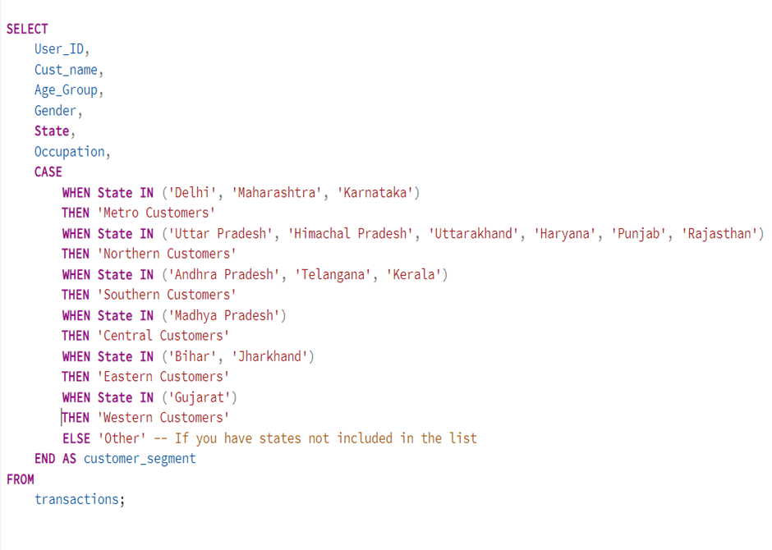

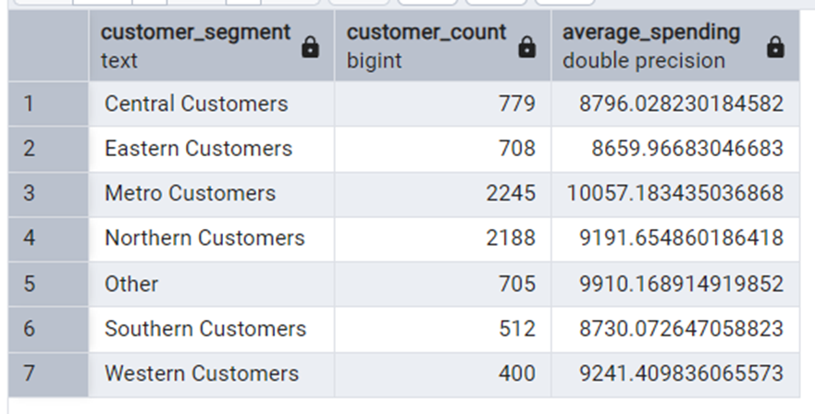

**8.2 Purchasing Habits of Customer Segments**

**Key Insights:**

1. **Order Volume:**
   * **Northern Customers** have the highest total orders (3,757), indicating a high frequency of purchases.
   * **Metro Customers** also have a substantial number of orders (3,938), which is close to the Northern Customers.
   * **Western Customers** have the lowest total orders (429), suggesting less frequent purchases.
2. **Average Order Value:**
   * **Metro Customers** have the highest average order value (10,057.18), indicating they spend more per order.
   * **"Other" Customers** also have a high average order value (9,915.17).
   * **Eastern Customers** have the lowest average order value (8,659.97).
3. **Order Value Range (Min & Max):**
   * The **Metro Customers** have the smallest minimum order value (189), suggesting a wider range of purchase sizes.
   * The **Southern Customers** have the highest minimum order value (761), indicating potentially less price-sensitive customers.
   * The maximum order value is relatively consistent across all segments, ranging from 21,079 to 23,952.
4. **Order Value Variability (Std Dev):**
   * The **Metro Customers** have the highest standard deviation (5,643.68), indicating the greatest variability in order values.
   * The **Western Customers** have the lowest standard deviation (4,798.33), suggesting more consistent order values.
5. **Total Spending:**
   * **Metro Customers** have the highest total spending (39,554,902.45), which aligns with their high order volume and average order value.
   * **Northern Customers** also have high total spending (34,514,664), due to their high order volume.
   * **Western Customers** have the lowest total spending (3,946,082), which is consistent with their low order volume.

**Purchasing Habits Summary:**

* **Metro Customers:**
  + High frequency of purchases and high spending per order.
  + Wide range of purchase sizes.
  + Greatest variability in order values.
* **Northern Customers:**
  + Highest frequency of purchases but moderate spending per order.
* **"Other" Customers:**
  + High spending per order but moderate frequency of purchases.
* **Southern Customers:**
  + Moderate frequency of purchases and moderate spending per order.
  + Potentially less price-sensitive customers.
* **Eastern Customers:**
  + Moderate frequency of purchases and lowest spending per order.
* **Western Customers:**
  + Lowest frequency of purchases and moderate spending per order.
  + Most consistent order values.

**8.3 Most Valuable Customer Segments**

**Key Metrics to Consider:**

* **Total Orders:** Indicates customer engagement and purchase frequency.
* **Average Order Value:** Represents the amount spent per order.
* **Total Spending:** Reflects the overall revenue generated by each segment.

**Analysis:**

1. **Metro Customers:**
   * Highest total orders (3,938).
   * Highest average order value (10,057.18).
   * Highest total spending (39,554,902.45).
   * **Conclusion:** Metro Customers are highly valuable due to their high volume of orders and high spending.
2. **Northern Customers:**
   * Second-highest total orders (3,757).
   * Moderate average order value (9,191.65).
   * Second-highest total spending (34,514,664).
   * **Conclusion:** Northern Customers are also very valuable, primarily due to their high order frequency.
3. **"Other" Customers:**
   * Moderate total orders(812).
   * High average order value (9,910.17).
   * Moderate total spending (8,037,146.99).
   * **Conclusion:** This segment is valuable due to the high average order value.
4. **Central Customers:**
   * Moderate total orders (923).
   * Moderate average order value (8,796.03).
   * Moderate total spending (8,101,142).
   * **Conclusion:** This segment is moderately valuable.
5. **Southern Customers:**
   * Low total orders (578).
   * Moderate average order value (8,730.07).
   * Moderate total spending (5,045,981.99).
   * **Conclusion:** This segment has moderate value.
6. **Eastern Customers:**
   * Moderate total orders (814).
   * Lowest average order value (8,659.97).
   * Moderate total spending (7,049,213).
   * **Conclusion:** This segment has moderate value.
7. **Western Customers:**
   * Lowest total orders (429).
   * Moderate average order value (9,241.41).
   * Lowest total spending (3,946,082).
   * **Conclusion:** This segment is the least valuable.

**Most Valuable Customer Segments:**

* **Metro Customers:** Are the most valuable, contributing the highest total spending and demonstrating strong purchasing habits.
* **Northern Customers:** Are also highly valuable due to their high order volume and significant total spending.

**"Other" Customers:** Are valuable because of their very high average order value

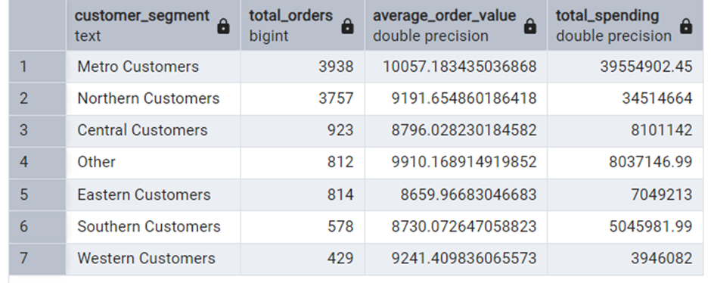

**Strategic Recommendation**

Based on the comprehensive analysis of Aditya Store's e-commerce festival sales data, the following strategic recommendations are proposed:

Customer-Centric Strategies:

1. Targeted Marketing:
   * Develop highly targeted marketing campaigns that cater to the specific preferences and needs of the dominant customer segments:
     + Females aged 26-35: Focus on fashion trends, lifestyle products, and personalized recommendations.
     + Unmarried Customers: Highlight products and services that align with their lifestyle, such as travel, entertainment, and personal care.
     + IT Sector Professionals: Offer specialized promotions and products that cater to their tech-savvy interests.
2. Customer Engagement and Retention:
   * Implement loyalty programs that reward repeat purchases and high-value customers.
   * Personalize email marketing and product recommendations to increase customer interaction and engagement.
   * Offer exclusive promotions and discounts to incentivize repeat purchases and build customer loyalty.
   * Create a customer feedback system to understand customer needs and preferences, and continuously improve the customer experience.

Product and Sales Optimization Strategies:

1. Inventory Management:
   * Ensure adequate inventory levels for popular product categories, especially "Clothing & Apparel," "Food," and "Electronics & Gadgets," to meet high demand and prevent stockouts.
   * Optimize inventory management for niche categories to minimize storage costs and reduce the risk of obsolete inventory.
2. Product Assortment and Diversification:
   * Continuously analyze product performance data to identify trends and adjust product assortment accordingly.
   * Explore opportunities to diversify product offerings and expand into new categories based on market trends and customer feedback.
   * Consider discontinuing or restructuring underperforming categories to optimize profitability.
3. Pricing and Promotions:
   * Analyze pricing and promotional strategies for different categories to identify opportunities for improvement.
   * Consider offering discounts or bundles to incentivize purchases in low-performing categories.
   * Implement upselling and cross-selling strategies to encourage customers to purchase higher-value items or complementary products.
4. Product Visibility and Discoverability:
   * Improve product visibility and discoverability for categories with high sales potential but low sales volume.
   * Consider using targeted advertising, search engine optimization, and product recommendations to enhance product visibility.

Operational Efficiency Strategies:

1. Regional Optimization:
   * Develop regional marketing campaigns and tailor product offerings based on zone-specific demand and customer preferences.
   * Optimize resource allocation and logistics to ensure efficient delivery and customer service across all zones.
   * Address operational bottlenecks in the Eastern zone to improve order fulfillment and customer satisfaction.
2. Supply Chain Management:
   * Optimize supply chain management to ensure timely delivery of popular products and minimize shipping costs.
   * Consider implementing inventory management systems to track stock levels and prevent stockouts.

Data-Driven Decision Making:

1. Continuous Monitoring and Analysis:
   * Continuously monitor customer data, sales data, and operational data to identify trends, patterns, and opportunities for improvement.
   * Use data-driven insights to refine marketing and product strategies, optimize pricing and promotions, and enhance customer engagement.
2. Key Performance Indicators (KPIs):
   * Track key performance indicators (KPIs) such as customer engagement, average order value, customer lifetime value, and conversion rates to measure the effectiveness of strategies and identify areas for improvement.

By implementing these strategic recommendations, Aditya Store can effectively leverage its customer base, product offerings, and operational capabilities to drive revenue growth, enhance customer satisfaction, and achieve sustainable success in the competitive e-commerce landscape.